**Project Name:**

**Crypto-currency notifier application**

**Project Type:**

**Bachelors of Computer Engineering. Engineering project II course project.**

**Project Team:**

* **AMMAR MOHAMMED (COMPUTER ENGINEERING)**

**Project Aim:**

**Using python specifically tkinter-GUI and API to use for creating a mobile application for sending a notification using email or other push-notification methods when crypto-currencies hit the desired value (price).**

**LAYOUT OF THE APPLICATION (USER INTERFACE):**

* **Log-in page:**

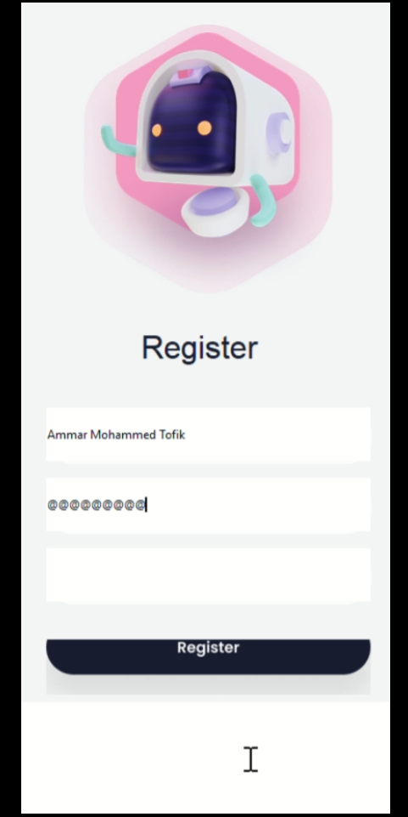

* **Home page (the page which links to all other interface):**

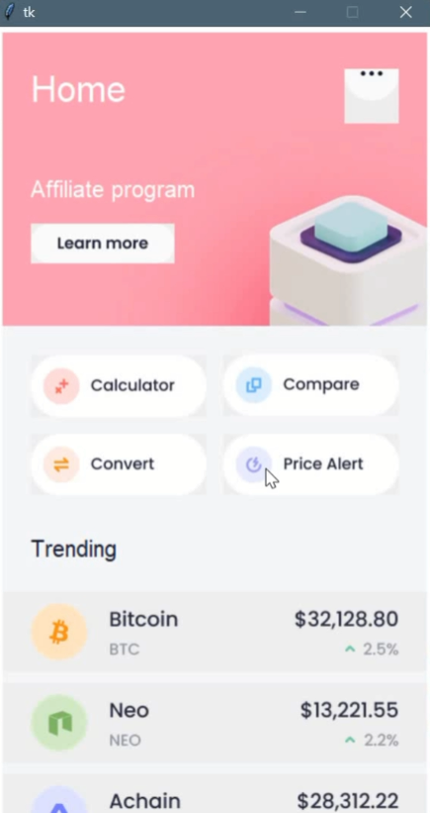

* **Page where the alert option shows for every crypto-currencies selected:**

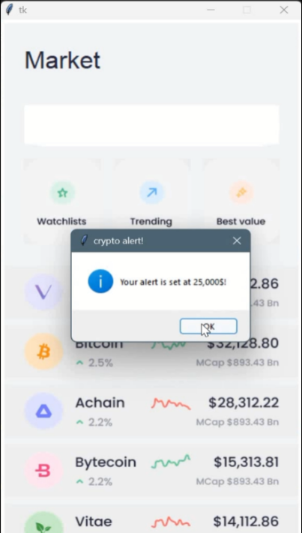

* **Page for insights:**

